



June 2025
Getting better use from infrastructure
  - How Victoria can improve its asset management

About us
Infrastructure Victoria is an independent advisory body with
3 functions:
- preparing a 30-year infrastructure strategy for Victoria, which we review and update every 3 to 5 years
- advising the government on specific infrastructure matters
- publishing research on infrastructure-related issues.
Infrastructure Victoria also helps government departments and agencies develop sectoral infrastructure plans.
Infrastructure Victoria aims to take a long-term, evidence-based view of infrastructure planning, and we inform community discussion about infrastructure provision.
Infrastructure Victoria does not directly oversee or fund infrastructure projects.
Acknowledgement
Infrastructure Victoria acknowledges the Traditional Owners of Country in Victoria and pays respect to their Elders past and present, as well as Elders of other First Peoples’ communities. We recognise that Victoria’s infrastructure is built on land that has been managed by Aboriginal people for millennia.



Contents
Summary 2
The Victorian Government should fund and prioritise better asset management 2
Getting value from infrastructure investments 3
Understanding assets and asset management 3
Understanding the asset lifecycle 3
How better asset management supports Victorian Government infrastructure 4
How the Victorian Government can use asset management 6
The organisations that look after Victorian government infrastructure 9
Why good asset management matters 11
The importance of long-term asset management to determine funding 13
Victoria’s Asset Management Accountability Framework 13
Guiding principles for government 14
Measuring government performance on asset management 15
Measuring compliance 15
Opportunities to improve compliance 17
Improving the government’s asset management performance 20
Recommendation: Improve asset management of all government infrastructure 21
Glossary 25
Appendix 1 26
Endnotes 27

Summary
When existing infrastructure no longer meets community needs, the Victorian Government must decide how to respond. Building new infrastructure is one option. But the government can also upgrade existing infrastructure, maintain it better or change how Victorians use it. This process is known as asset management.
Looking after infrastructure is a challenge that spans decades. Each piece of infrastructure has its own lifespan, changing needs and uses over time. Different types of infrastructure need different management approaches, based on where they are, how they were built and what they do now.
Good asset management helps the government make the most of infrastructure investments. It ensures new projects are efficiently built and meet both current and future service needs. When asset management works well, the government can adapt more easily as conditions and community needs change and as we move to a circular economy and build climate resilience.
The Victorian Government owns about $400 billion worth of infrastructure and land. With many new projects under construction, the value of government infrastructure will grow. Maintenance costs will also go up.
To handle this growth, and keep infrastructure reliable, safe and cost-effective, the government needs to:
- fully understand the condition of its infrastructure
- strengthen asset management practices across all agencies
- support asset managers to manage infrastructure effectively.
These improvements would help better use public money and reduce risks.

The Victorian Government should fund and prioritise better asset management
In Victoria’s 30-year infrastructure strategy, Infrastructure Victoria recommends improving asset management of all government infrastructure.
We recommend funding asset managers to better understand the condition, use and performance standards of all government infrastructure. The Victorian Government can use this information to develop asset management strategies and prioritise future funding.

Getting value from infrastructure investments
Asset management makes government services better by making infrastructure more reliable and useful for Victorians. It gives government the information it needs to make smart decisions about managing, building, maintaining, upgrading or decommissioning infrastructure.

Understanding assets and asset management
The Victorian Government defines an asset as “an item or thing that has potential value to an organisation, and for which the organisation has a responsibility”.
Assets can be:
- physical, built infrastructure such as roads, buildings, utilities and communications equipment
- natural assets including forests, rivers, marine areas and farmland
- cultural assets including historic places and objects
- non-physical assets such as intellectual property, goodwill or financial assets.
Asset management is a structured way to get the most benefit from investments. The Victorian Government defines it as “the coordinated activities of an organisation to realise lifecycle value from assets in delivery of its objectives”.
To get the best benefit from assets, organisations need to:
- align strategic, tactical and operational areas
- consider short, medium and long-term asset needs
- manage assets throughout their useful life
- balance performance and cost using risk frameworks
- coordinate their asset decisions.

Understanding the asset lifecycle
Assets follow a lifecycle from planning to disposal or replacement. This process happens whenever the government upgrades, builds or buys infrastructure like roads, trains or hospitals.
The asset lifecycle (see Figure 1) has 4 stages:
- Planning – The government identifies what’s needed and plans how to get it. This includes deciding what type of asset will work best and how Victorians will use it.
- Acquisition – The government buys, builds or develops the asset.
- Operation – The government delivers, runs and maintains the asset to deliver services. Regular maintenance keeps everything in good condition and working properly. Sometimes the government partners with other organisations to manage assets during this stage.
- Disposal – Eventually, the asset reaches the end of its useful life. This is when an asset no longer works effectively, or service needs have changed. At this point, the government might sell, repurpose, recycle or dispose of it. Or the government might renew or replace it with something new, starting the cycle again.
For this process to work well, there needs to be clear leadership and accountability across all 4 stages.
Figure 1: The 4 key stages of the asset lifecycle
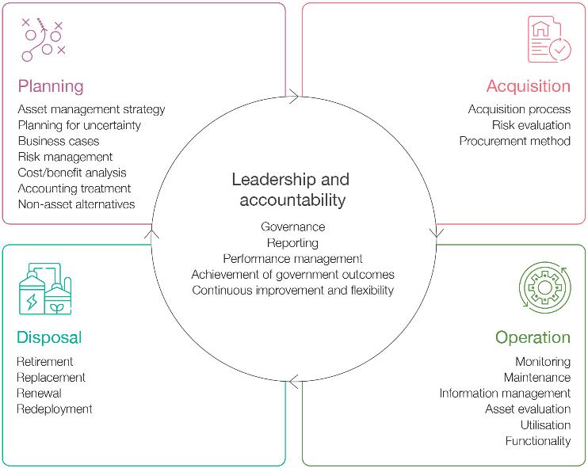
Source: Infrastructure Victoria, adapted from Department of Treasury and Finance, Asset management accountability framework, State of Victoria, February 2016, p 7, accessed 20 January 2025.
Asset management is more than just maintaining what you already have.
While maintenance is important, decisions about buying new assets or retiring old ones are equally important parts of the asset management lifecycle.

How better asset management supports Victorian Government infrastructure
This report focuses on infrastructure assets owned by the Victorian Government for public use or benefit.
Infrastructure, like roads, schools, hospitals and transport networks, supports services that Victorians rely on every day. These assets create jobs, help businesses grow and attract investment. They connect people to healthcare, education and other essential services while keeping communities safe and connected. Without proper asset management, these services could become unreliable.
The Victorian Government manages a large portfolio of infrastructure. In 2024 the Department of Treasury and Finance estimated the government’s infrastructure and land assets were worth around $400 billion. These assets are crucial for delivering public services. Managing them efficiently ensures they keep benefitting Victorians.

We have provided an approximate value of existing government infrastructure, by sector, in figure 2. The figures exclude land values and show how much infrastructure must be managed. Additionally, the figures are based on financial reporting ‘fair value’ calculations, rather than replacement costs.
Victoria’s transport infrastructure has the largest value at around $150 billion (see Figure 2). This includes the state’s roads, trains, trams, buses and supporting infrastructure. Water infrastructure has the second largest value at about $53 billion. These numbers highlight the enormous value of Victoria’s assets and how much needs to be managed.

Figure 2: Approximate value of Victorian Government infrastructure, by category
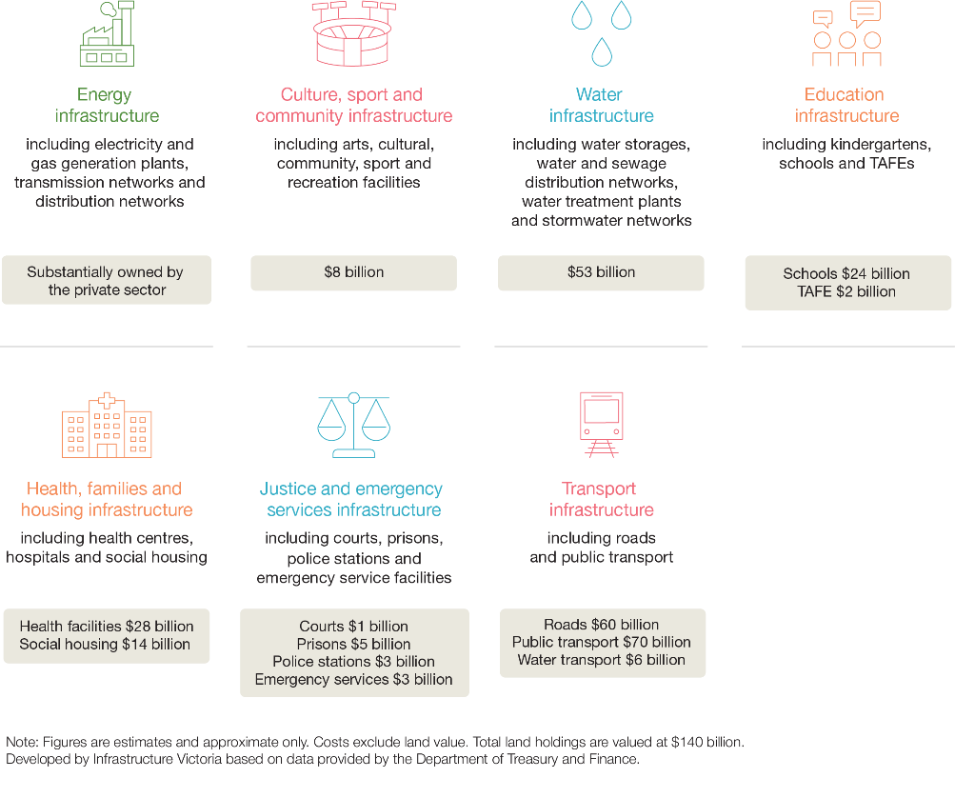
The value of environmental infrastructure or natural assets owned by the Victorian Government is not calculated in this report. However, the value of state government owned land used for parks and forest is approximately $10 billion.
The Victorian Government uses asset management to look after its large portfolio of assets. This report does not address local government owned and managed infrastructure.

How the Victorian Government can use asset management
Asset management helps the government know what infrastructure it owns and the condition it is in. Better information helps the government make good decisions about buying, building or fixing assets. When asset management works well, organisations clearly understand their infrastructure, its purpose and risks and how to manage it with regular reviews.
Asset management is not about keeping everything perfect – it is about meeting goals and making sure infrastructure supports service delivery. How much to invest depends on what the infrastructure does and what would happen if it failed. For essential facilities, like major hospitals, the government might spend more to make them last longer without service interruptions. For temporary needs, like COVID-19 vaccination centres used short term during the pandemic, spending less makes sense even if the asset condition is not perfect.
When considering competing priorities, the Victorian Government can use asset management to make better spending choices. This might mean delaying its spend on some things or accepting fewer immediate benefits. Sometimes, it means finding new ways to use existing infrastructure.
Asset management can also save money. When critical infrastructure breaks it needs to be fixed urgently. Emergency repairs can cost much more than planned works. The chance to improve, rather than just fix, the infrastructure is also lost. Asset management allows the government to look ahead and plan what is needed.
The government can also consider options to improve performance and reduce the cost of failure by spending more on infrastructure initially or during its operational life. If asset management is done well, this increased spending on infrastructure will save money for the services it supports.
South East Water’s digital water meter project is an example of this (provided in the case study on the next page). The case study shows investing in digital rather than standard meters saved money long term.

Case study
Asset management focus reduces costs at South East Water with digital meters
Water scarcity and climate change are increasing the need to better manage and use water. Approximately 10% of Melbourne’s water supply is lost in the water pipe network. Sometimes it is used for good reasons, such as when firefighters tap into the water network to fight fires. However, much water is lost due to pipes leaking or bursting.
Taking an asset management approach, South East Water considered this problem and identified the benefits of installing digital meters for all their customers. The meters identify when a leak first occurs and how serious it is.
Benefits identified include:
- avoided potable water losses due to reduction in customer side leaks
- avoided potable water use due to customer behaviour change
- avoided potable water losses due to reduction in leaks in South East Water’s network
- avoided capital costs in South East Water’s network
- avoided South East Water operating cost.
Benefit-cost ratio: 1.37

The meters can detect leaks in the water supply network and on private property. The meters save customers money from lost water and also provide information to help consumers change their behaviour to use less water.
The digital meters cost 2 to 3 times more than a standard meter but save money overall. Money is saved by reducing water losses and avoiding the costs of pipe networks failing. South East Water calculated that every $1 spent on digital water meters results in $1.37 of benefits.
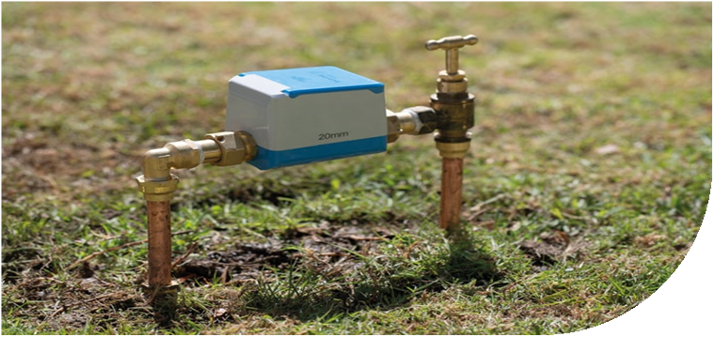
Image below: a digital meter installed at Caulfield South, Victoria.: South East Water.

Governments can also involve communities in the asset management decision-making process. MidCoast Council in New South Wales recently did this to test how community members may choose to balance service vs cost in the case study below.

Community input helps identify asset management priorities  The MidCoast Council in New South Wales assessed its infrastructure assets and came up with options for how to manage them.  The council gave information about poor, satisfactory and good outcomes and the costs to get those outcomes.  It then asked local communities about what performance they expected from those assets. They also asked what people would be willing to pay.  Most people wanted the council to maintain the infrastructure to a satisfactory condition, rather than an improved condition.  An exception was roads. Community members were split with half wanting roads maintained to a satisfactory condition and half wanting an improved condition at a greater cost. | 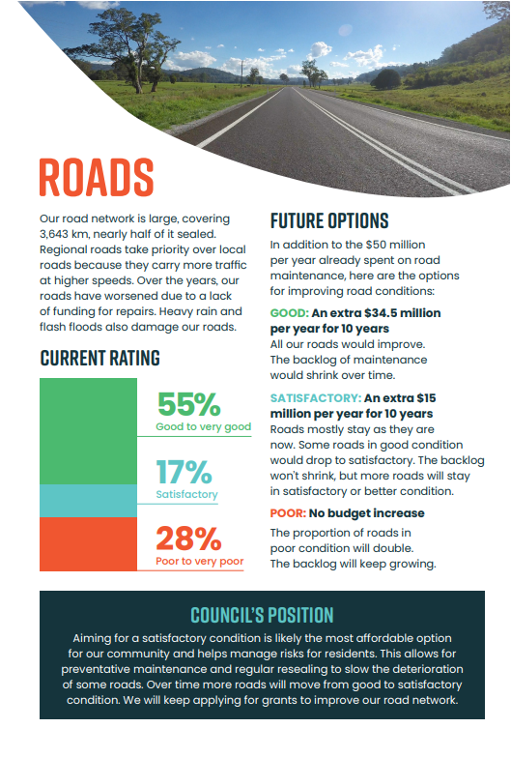

Managing government infrastructure well involves making smart decisions about building, maintaining, fixing and adapting assets over time. This keeps infrastructure working safely and efficiently for the public.
Well-managed assets stay in a satisfactory condition, work efficiently and meet Victorians’ needs. Good asset management prevents unexpected breakdowns and helps deliver reliable services that communities can count on.

The organisations that look after Victorian government infrastructure
Many public and private organisations share responsibility for managing Victorian government infrastructure, each with their own priorities and areas of focus. Their roles sometimes overlap.
The main organisations involved in asset management of Victorian government infrastructure are:

The Department of Treasury and Finance and Department of Premier and Cabinet
The Department of Treasury and Finance and the Department of Premier and Cabinet advise on whole-of-government asset management issues. Their role is especially important during the planning and disposal stages of the asset lifecycle. These departments coordinate and advise on the annual budget process that decides how much funding is available for infrastructure investment. They are sometimes known as ‘central agencies’.
They also manage their own infrastructure assets. Compared to other departments, their assets are generally less valuable. Their role in decision making across whole-of-government asset management is more significant.

Departments
Other Victorian Government departments focus on specific services like health, education and transport. These departments look after assets in their areas of responsibility and develop management plans covering all 4 stages of the asset lifecycle. They work with the Department of Treasury and Finance and Department of Premier and Cabinet when planning new assets or disposing of old ones, and they partner with service providers during the operational phase.
Departments remain responsible for making sure infrastructure is meeting community expectations. They are responsible to the public and portfolio Ministers.
In this report we include public entities when we talk about departments. We do not mention them separately. We refer to ‘agencies’ when we mean all Victorian Government departments, public entities and other public bodies. This is consistent with the Victorian Asset Management Accountability Framework.

Service providers
These are the organisations that deliver services using government infrastructure. For example, while the government might own hospitals or public transport infrastructure, a public or private organisation often runs them. Service providers include government organisations such as healthcare agencies and government schools, or private companies like Metro Trains (which runs Melbourne’s metropolitan trains) and Yarra Journey Makers (which operates trams).
Their responsibilities vary depending on the service. Service providers typically handle the day-to-day operations, including monitoring how infrastructure is used, maintaining it, managing information and identifying when upgrades are needed.
Figure 3 shows how the Department of Treasury and Finance and Department of Premier and Cabinet interact with other departments in the asset management process.
Figure 3: Relationship between the asset management lifecycle and organisations’ responsibilities
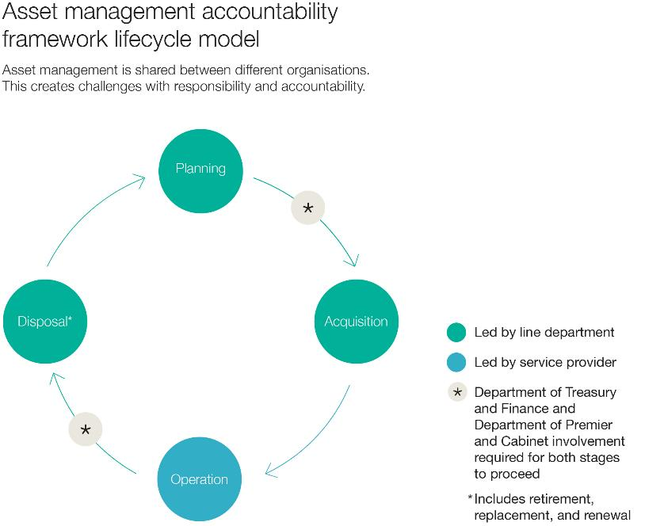
Source: Infrastructure Victoria.
When service providers share asset management responsibilities, it adds complexity because decisions must be made between more organisations. However, this approach can deliver better overall outcomes.
Take hospitals as an example. Health service providers have detailed knowledge of what patients and staff need from the infrastructure day-to-day. When these providers take responsibility for managing infrastructure during the operational stage, health service delivery becomes the priority in infrastructure decisions. When done well, the infrastructure supports health services, rather than health services having to work around infrastructure limitations.
Departments hand over some asset management responsibilities to service providers but remain responsible to the public and their portfolio Ministers for the long-term asset management performance. This makes sure infrastructure supports effective and essential service delivery.

Why good asset management matters
Victoria’s infrastructure faces several key challenges that better asset management can help address.

Ageing infrastructure
Some of Victoria’s infrastructure is old. One example is Melbourne’s sewerage network. Some of these assets were built before the 1970s and are reaching the end of their expected design life. These assets can keep working well if we understand their condition and apply upgrades like increased maintenance or targeted works. Most of our sewers sit in and around highly built-up areas. This makes replacing or renewing these assets complex and requires careful planning. Water corporations work together to maintain services and minimise the impact of upgrades to Victorians.
The Victorian Government needs good asset management strategies to make sure that our older assets are replaced or maintained to still deliver services cost-effectively.

Climate impacts
Extreme weather events and a changing climate create more risks for infrastructure. The original design conditions are changing, requiring adaptation of existing infrastructure. Our report, Weathering the storm: adapting Victoria’s infrastructure to climate change, explores these challenges.
Adopting good asset management means we know the condition of our infrastructure and how it needs to perform in the future. This helps the government to adapt and future-proof its infrastructure.
Climate change impacts infrastructure  Victoria’s climate is 1.2°C warmer than in 1910. The state now has a drier climate with more frequent and intense weather events. These include heatwaves, floods and dangerous fire seasons. As global temperatures rise, severe weather becomes more common and damaging.  Climate change threatens Victoria’s infrastructure in many ways. Bushfires can destroy buildings, power lines, phone towers, roads and rail. Floods damage buildings and wash away roads and bridges. Storms can knock trees onto power lines and roads, tear off roofs and break windows. Rising seas threaten coastal infrastructure with storm surges, flooding and erosion. These events will worsen as climate change intensifies. | 

Circular economy
Victoria wants to move to a circular economy, but we're creating more waste than ever. Waste doubled from 7.4 million to 14.4 million tonnes between 2000 and 2018, with about 30% going to landfill. To fix this, we need to produce less waste and think differently about how we manage our resources. Good asset management uses buildings, equipment, and infrastructure in the smartest way possible - balancing costs, risks, and how well they work. In a circular economy, this means keeping assets and their components in use for as long as possible by repairing, reusing, and recycling them instead of throwing them away. Asset management allows the use of fewer new resources by making things last longer.

Decarbonisation
Up to 70% of Australia’s annual greenhouse gas emissions relate to the lifecycle of infrastructure through operational, enabled, and embodied emissions. The Victorian Government wants to reduce emissions, improve productivity and support industry development. A key principle in achieving these goals is to get better use from existing infrastructure or modify it to meet changing needs before considering a new build.
Our report Opportunities to reduce greenhouse gas emissions of infrastructure explains how the Victorian Government can update policies, guidelines and procedures to make carbon emissions count in infrastructure decision-making. This includes planning, design, construction, maintenance and the end-of-life of Victoria’s infrastructure.

Population growth
Victoria is Australia’s second-fastest growing state. It is expected to reach 10.3 million people by 2051. This means more demand on existing transport networks, schools and hospitals. Planning for expansion or upgrades is essential.
Our research, Learning for life: preparing kindergarten, school and TAFE infrastructure for the future, found Victoria will need around 900 new kindergartens, up to 60 new government schools and 20% more TAFE teaching space by 2036. Better asset management would help ensure this infrastructure and other new investments meet growing needs.
The government can also decide to do things differently. For example, in Learning for life we recommend the Victorian Government continue to build new schools to house more students on one campus. Good asset management allows for exploring different options in the planning stage, like building schools to house more students, saving on land costs without compromising on student’s needs.

Technological change
New technologies offer both opportunities and challenges. They can improve how assets perform but might need investment in new equipment, system updates and staff training. Modern tools, like robots and artificial intelligence, can also support better data collection and analysis. Our report, Digital technology and infrastructure productivity, looks at how some of these technologies can impact infrastructure.

The importance of long-term asset management to determine funding
The Victorian Government does not currently report how much it spends on renewing and maintaining infrastructure. Based on average depreciation rates, about $5 billion might be needed each year. Without good data on asset conditions, the government cannot identify where investments will deliver the best results. This wastes money and creates risk for people and businesses.
Infrastructure Australia’s 2019 audit highlighted this challenge:
There is little doubt that a maintenance backlog exists across many parts of our infrastructure networks, although the extent varies by sector and region. Some of the maintenance backlog is evident to users of many roads and bridges that suffer from poor upkeep, particularly in regional areas, causing safety risks, reliability issues and adding to vehicle costs. The causes of the maintenance backlog are diverse. In some cases, the absence of cost recovery arrangements means that there is no mechanism linking usage (which drives the physical depreciation of assets and the need for maintenance) with a direct funding source to undertake repairs. In other cases, the backlog has been caused by governments prioritising the construction of new assets or failing to undertake preventative maintenance – leading to higher costs for reactive maintenance.
When there are budget pressures, asset management can help the government choose which infrastructure projects to fund. This approach makes sure taxpayer dollars offer the greatest benefit. It can also help to identify unnecessary infrastructure, allowing the government to stop spending money maintaining these assets.

Victoria’s Asset Management Accountability Framework
All Australian states and territories use similar approaches to managing infrastructure assets, but each has its own system.
In 2016, the Victorian Government published its own framework called the Asset Management Accountability Framework (AMAF). Victorian agencies must use this framework to better manage their assets. The framework includes mandatory requirements and useful guidance. It aims to make sure infrastructure delivers the best value for money, operates efficiently and is managed responsibly.
The framework applies to all physical assets owned by the Victorian Government. Agencies must use the framework to identify:
- what services are needed now and in the future
- what assets they need
- what risks these assets might face.

Guiding principles for government
The Asset Management Accountability Framework includes 6 guiding principles for agencies:
- Service delivery focused – the framework helps agencies deliver services Victorians depend on. For example, this could mean making sure Victoria has enough trains to run reliable services and planning hospital infrastructure to meet the needs of a growing population.
Figure 4: Service delivery is at the core of asset management
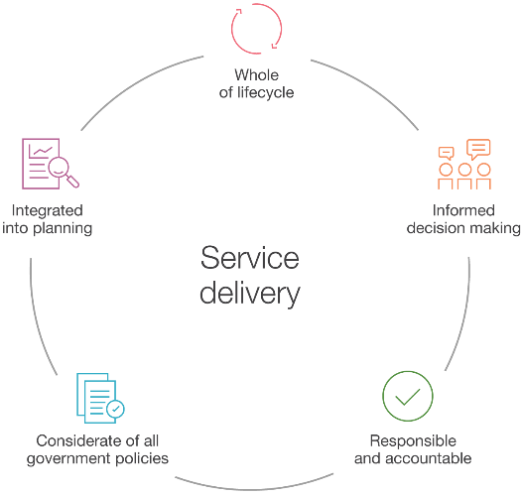
Source: Infrastructure Victoria, adapted from Department of Treasury and Finance, Asset management accountability framework, February 2016, p 4, accessed 3 February 2025.
- Integrated into planning frameworks – this connects asset management with other government policies and frameworks, including budget processes.
- Whole-of-lifecycle approach – this makes sure agencies manage assets properly at every stage, thinking about all costs throughout assets’ lifecycles.
- Informed decision making – to meet service goals, agencies must explore all available options for their assets and track the outcomes of their management choices.
- Responsible and accountable – agencies need to understand and communicate everything their assets need to do.
- Considerate of government policies and priorities – asset management decisions must align with the government’s broader objectives and priorities.
The Asset Management Accountability Framework aims to efficiently deliver services by making sure assets are suitable for their purpose. When agencies follow this framework, they can get the right assets in the right places, at the right time, for all Victorians. This approach can deliver the best value for money while properly managing asset risks.

Measuring government performance on asset management

Measuring compliance
Victorian government departments and agencies are slowly getting better at managing their assets. This improvement takes time, effort and money.
When the government published its framework in 2016, it gave agencies 4 years to improve how they manage their assets before assessing compliance and performance. Agencies had to confirm they met the framework by 2018 and publish their first detailed self-assessment in 2021.
Figure 5: Relationship between the asset management accountability framework, improving asset management, and compliance
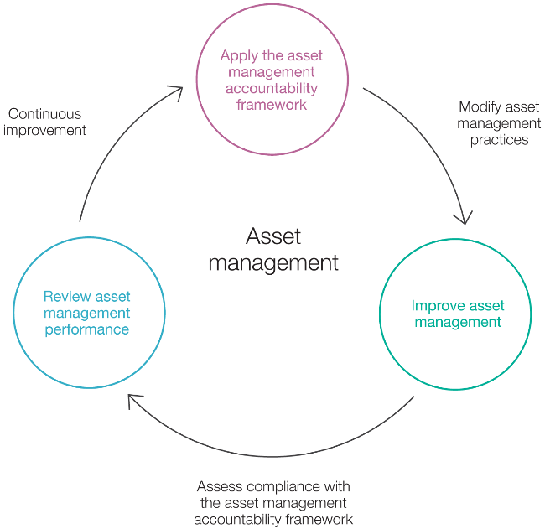
Source: Infrastructure Victoria, adapted from Victorian Auditor–General’s Office, Compliance with the asset management accountability framework, May 2019, p 21, accessed 2 December 2024.
The framework requires agencies to:
- report each year on whether they meet the framework
- complete a detailed maturity self-assessment every 3 years.
From 2018, agencies had to report any major problems in their public annual reports. In 2019, the Victorian Auditor-General’s Office checked how well 7 departments were using the framework. They found departments were just starting to use it and needed to keep improving.
Since 2021, agencies must publish detailed maturity self-assessments in their annual reports at least every 3 years. They rate themselves against 41 required items in the framework.
Figure 5 shows these ratings as a pinwheel format. It compares what agencies aimed for with what they achieved. All agencies use the same rating system, so their results can be compared. Not all agencies need to reach the highest level – it depends on how important their assets are and other factors.
Agencies rate themselves on a scale from 0 to 4:
- 0 – innocence
- 1 – awareness
- 2 – developing
- 3 – competence (meets requirements)
- 4 – optimising.
Some agencies still haven’t reached level 3.
Figure 6: Example of the pinwheel, the way that agencies report their asset management maturity in their annual report
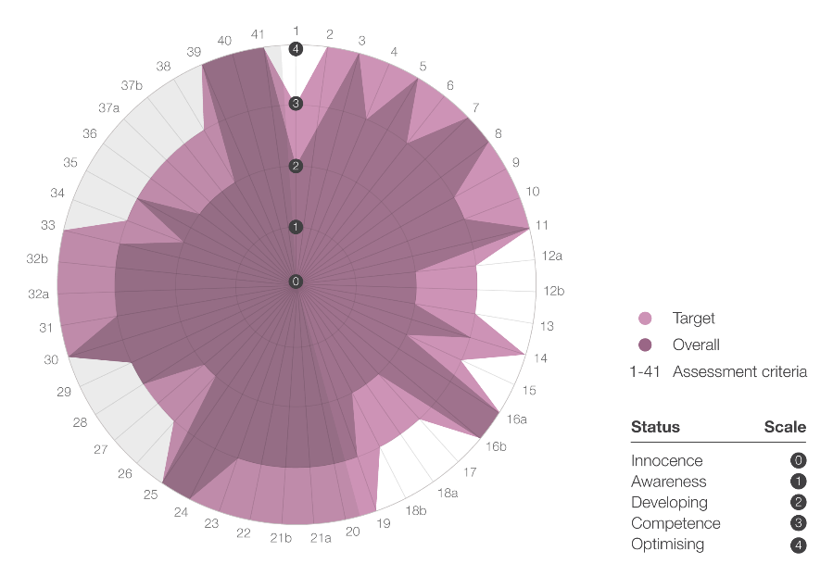
Source: Infrastructure Victoria, adapted from Victorian Government departments’ annual reports, 2020–21 and 2023–24.
Departments showed different levels of skills in asset management through the new self-assessment approach. This is partly because departments manage different types and amounts of assets. For example, the Department of Transport and Planning manages the biggest share of government infrastructure - Victoria’s critical roads and public transport system. This includes different types of assets such as roads, rail lines, communication networks, buildings, trams, trains and buses. This makes asset management harder as a bigger and more varied infrastructure base needs more people and a broader skill set to undertake good asset management.

Opportunities to improve compliance
Departments’ results vary from 2021 to 2024.
In 2021, during the COVID-19 pandemic, results ranged from 2 (developing) to 4 (optimising). After 3 years, there are still opportunities for some departments to improve their framework compliance.
In 2024, some departments reported their assessments differently. The Department of Transport and Planning gave itself a rating of 2 (developing), without including the standard pinwheel diagram. The Department of Premier and Cabinet rated itself as 3 (competent) with few details. More detailed reporting would better show areas of strength and where improvements could be made.
Figure 7 compares the 2021 and 2024 results for most government departments. The 2022 government restructure changed some departments’ names. While 4 out of 7 departments improved their overall scores, others stayed the same or dropped slightly.
Figure 7: Victorian Government departments’ 2021 and 2024 asset management accountability framework self-assessments
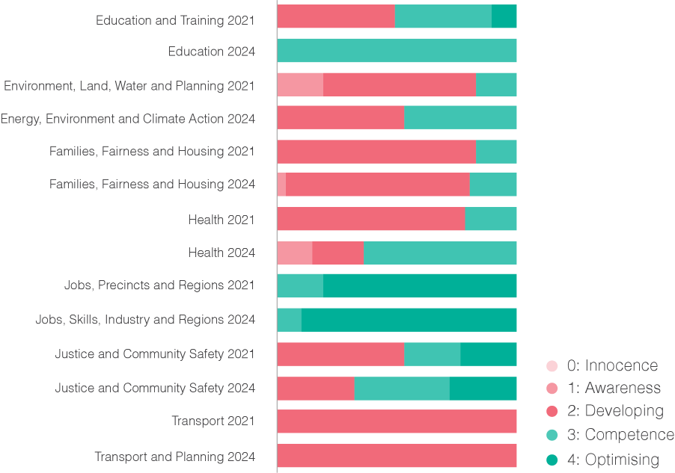
0: Innocence
1: Awareness
2: Developing
3: Competence
4: Optimising
Source: Infrastructure Victoria, based on analysis of Victorian Government departments’ annual reports, 2020–21 and 2023–24.
Comparing results between 2021 and 2024, many scores remain steady. Larger departments, like transport and planning and health, manage billions of dollars in assets but still do not meet all framework requirements, despite the time available to improve.
A New Zealand Infrastructure Commission study identified that people are the biggest constraint in improving infrastructure asset management maturity. The study listed workforce shortages, leadership, governance and the ability for asset managers to present evidence to decision makers as contributing issues.

Our recommendation in this report and Victoria’s 30-year infrastructure strategy suggests how more funding for asset management could help departments improve.
New South Wales gives a helpful example, having made good progress over 6 years. Since starting its Asset Management Policy in 2019, NSW has built stronger asset management skills. The following case study shows its approach and achievements.

Case study
Australian states are integrating asset management with their funding decisions
The New South Wales Government has reformed its approach using strategic asset management planning and annual budget processes. Like Victoria, New South Wales faces budget pressures and has many infrastructure projects under way. By integrating asset management with funding decisions, New South Wales can prioritise projects that deliver the most benefit.
New South Wales has established a major infrastructure project pipeline – a public list of priority projects showing the community what is planned and expected costs. In 2023, Infrastructure NSW expanded this list to include upcoming major asset management projects. This transparency helps the community understand why projects proceed and how decisions are made.
But these decisions can only be made when the government has enough data. Victoria does not have comparable information on its infrastructure’s condition. Creating a similar database would help Victoria to improve transparency around infrastructure projects.
The major project pipeline helps the New South Wales Government forecast how much it needs to spend. Including asset management projects helps agencies plan how much money they need in advance. This approach encourages better asset management by making agencies think about long-term infrastructure needs. It also requires agencies to explain how their assets support service delivery, so projects can be prioritised on that basis.
Image below: Sydney Light Rail. Source: Infrastructure Victoria.



Improving the government’s asset management performance
Infrastructure Victoria recommends the Victorian Government improve asset management of all government infrastructure.
Recommendation: Fund asset managers to better understand the condition, use and performance standards of all government infrastructure. Use this information to develop asset management strategies and prioritise funding.

Recommendation: Improve asset management of all government infrastructure
Fund asset managers to better understand the condition, use and performance standards of all government infrastructure. Use this information to develop asset management strategies and prioritise funding.
Victorian Government departments are inconsistent in how they track and manage their assets. Governance structures are appropriately structured around service delivery. However, infrastructure investment decisions are often made with a 30 to 50 year horizon and must be regularly reviewed to provide value. Currently, infrastructure decision making relies on incomplete asset data. Without a consistent system, asset managers find it hard to monitor infrastructure performance and manage risks, including unexpected service interruptions.
Poor data can lead to asset management mistakes, such as:
- repairing or replacing assets unnecessarily
- missing maintenance needs, causing asset failures
- spending money extending the life of infrastructure that should be replaced.
These issues can lead to higher spending for lower value.
In the operational phase, departments often give infrastructure asset management responsibilities to service providers. These arrangements vary by infrastructure type, location and supported services. This handover complicates asset management and can cause departments to lose influence and knowledge over the infrastructure portfolio they are responsible for.
Departments and service providers often have different infrastructure management priorities. Asset management plans and service providers performance management plans can help align these priorities. In 2024, 3 departments owning about 60% of the government’s infrastructure reported they did not have appropriate processes to allocate asset management responsibility.
Evidence also shows departments could better monitor the condition and use of their assets. In 2024, 4 departments owning about 75% of the government’s infrastructure reported they did not have adequate processes for collecting data and managing service providers’ asset management performance.
The case study on Melbourne’s railway assets also highlights these issues.
The Victorian Auditor–General Office’s audit of Melbourne’s railway asset management  In 2023, the Victorian Auditor–General’s Office (VAGO) audited Metro Trains Melbourne’s (Metro) to see how well it maintains the city’s train network. The audit also looked at how the Department of Transport and Planning manages the network.  The audit found Metro is doing a good job of maintaining the train network. Its work helps ensure trains run on time and passengers stay safe.  However, the Department of Transport and Planning has no effective way to measure how well it manages the network. While the department has performance measures in its agreement with Metro, some are not helpful. Without good tracking and reporting, the department cannot tell if Metro offers good value for money. The department needs better information to make sure Metro:  - makes needed improvements  - maintains assets at reasonable cost  - fixes performance problems.  The department accepted the 10 VAGO audit recommendations. | 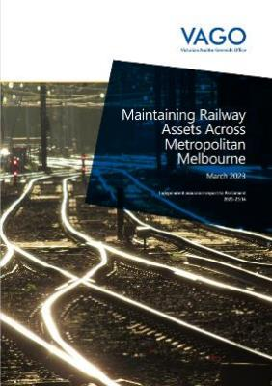
More active management and support of service providers will help departments improve their asset management and benefits to the community.
Make asset management plans
Departments need good asset management plans to deliver better services and maximise the benefit from infrastructure. These plans connect what organisations want to achieve with what they know about their infrastructure.
Most departments already meet the basic requirements for these plans. But many do not have complete information about the condition and performance of their assets. This makes it hard to plan properly for upgrades, new purchases or disposals of assets. Better data will help them improve their plans.
Departments need to improve their plans so service providers understand what is expected. This might mean setting specific goals, like keeping services running without interruption or keeping the asset until a specific date. Departments also need to create systems to measure asset management performance and make sure service providers report regularly.
Set up consistent standards and systems for data collection and reporting
The 2024 assessments showed that more than half of government departments do not have good ways to consistently collect data. Collecting infrastructure data is hard because it comes from many different sources about many types of assets.
Departments should specify exactly what data they need. This makes collecting and storing information easier. Good data helps departments make decisions and report to the Department of Treasury and Finance and Department of Premier and Cabinet. For example, departments need to know if maintenance is done as planned, not exactly when it happened.
Departments need to decide what information service providers must share with them. Service providers need efficient ways to collect and share this information.
Both departments and service providers will need to invest in data sharing and analysis. Staff will need training to use asset management systems. The Department of Education has taken this approach, as detailed in the case study below.
Create a central asset management knowledge base
Departments must store data so it is easy to access and understand.
Asset management guidelines already exist for managing infrastructure efficiently. Modern software systems and technology make this easier. Organisations need to store and analyse data to understand and manage their infrastructure well.
The 2024 assessments showed that more than half of government departments lack good information about their assets’ condition and performance.
The Victorian Government should fund departments to develop central asset management knowledge bases. This will help them move away from spreadsheets to asset management software with more capability giving them better information about their infrastructure.
Build staff skills
Even with better data, departments need people who can understand and use it. Some departments do not have enough staff with asset management skills. They struggle to assess assets, create plans and track performance. This can also lead to poor use of funding for upgrades or maintenance.
The AMAF framework describes improvements as a ‘maturing’ process that takes time and effort. Some agencies still do not meet the basic requirements. Staff need training and chances to learn from others. Departments can also do more to help service providers build their skills, which is a role given to them under the AMAF framework. The asset management profession also has existing formal training and accreditation schemes to support this skills development.

Cost, timing and benefits
By funding better asset management, we will get more benefits from our infrastructure. We estimate improving asset management will cost $150 million to $250 million over 5 years. This is about 0.05% of the $400 billion worth of infrastructure and land managed by the Victorian Government. Improving asset management includes allocating staff, developing standards and systems, collecting data and creating strategies and business cases. General government revenue can fund this recommendation.
Asset managers will need more funding to plan beyond 2030 and for future infrastructure upgrades and maintenance. They may also need more funding to renew or maintain some infrastructure. Our estimates do not include these additional costs.

Case study
Collaboration and a preventative approach better support school asset management
Victoria’s school buildings assets include over 1,580 schools, 26,000 buildings, land and other assets valued at over $24 billion in 2024. The Department of Education identified a $420 million maintenance backlog in 2012. A 2017 audit attributed the backlog to government underfunding, a lack of attention to maintenance by schools and differences in school leaders’ asset management capability.
Victorian Government schools adopted a devolved governance model in the 1990s, giving individual schools control over decision-making, including asset management. But this model did not help schools develop the skills and systems needed to keep up with modern asset management practices. In response, the department has shifted toward providing more support to schools, with better oversight and resources to develop shared systems and processes.
The department established the Victorian Schools Building Authority in 2016 to oversee school design, construction and upgrades. It updated its asset strategy in 2018 and moved to a shared responsibility model. Individual schools manage the majority of maintenance, while the building authority gives school principals support with asset management assessments, maintenance planning and scheduling through a central IT system, training and assistance, more centrally delivered maintenance programs and direct support for small schools.
This approach recognises that schools can be managed effectively locally, as principals and school communities understand their unique needs. The central IT system helps the department monitor the condition of school buildings and use this information to guide maintenance tasks, direct funding to high-priority maintenance and make better decisions about capital funding.
The Asset Management Reform program aims to move from reactive, backlog-driven maintenance to a preventative approach. In 2024, the department achieved full compliance with the Asset Management Accountability Framework. It has now moved to a second phase of improved asset management for schools. The reforms offer valuable lessons for other government agencies where service providers manage infrastructure and want to strengthen their asset management practices.
Image below: A family at a government primary school. Source: Infrastructure Victoria.

Glossary
Term | Definition
agency or agencies | Victorian public sector departments, public entities, agencies, corporations, authorities and other bodies that are captured by the Standing Directions of the Minister for Finance made under the Financial Management Act 1994.
asset | An asset is an item, thing or entity that has potential or actual benefit to an organisation. Asset categories include physical assets such as built infrastructure including roads, buildings, utilities and information technology systems; natural assets such as forests, rivers, marine areas and farmland; and intangible assets such as intellectual property, goodwill or financial assets.
asset management | The coordinated activity of an organisation to realise benefit from assets.
critical asset | Critical assets (physical, data/information, intellectual, process, technology) are those that are essential for supporting the social and business needs of both the local and national economy.
government infrastructure | Infrastructure owned and managed by the Victorian Government.
infrastructure | Infrastructure is the set of systems and assets that serve people. Infrastructure ranges from things like roads, trains and buildings to telecommunications networks and digital systems.
infrastructure lifecycle | The process from the beginning of design to the end of the asset’s life, including planning, development, construction, use, and decommissioning.
maintenance | Incremental work to repair or restore infrastructure to an earlier condition or to slow the rate of deterioration. This is distinct from construction and upgrading, which seeks to extend infrastructure beyond its original condition.
Sources: Victorian Public Sector Commission, Victorian public sector, 2022; Department of Treasury and Finance, Asset management accountability framework, 2016; International Organization for Standardization, ISO 55000:2024 – Asset management – vocabulary, overview and principles, 2024; New Zealand Infrastructure Commission Te Waihanga, Asset management state of play, 2024; Infrastructure Australia, Infrastructure glossary, 2025.

Asset management maturity rating by department in 2021 and 2024 as displayed in Figure 7
Department | Distribution of self-assessment rating for the 41 criteria  (note 6 criteria have sub criteria resulting in a total of 47 ratings)
 | 0: Innocence | 1: Awareness | 2: Developing | 3: Competence | 4: Optimising
Department of Education  and Training 2021 | 0 | 0 | 23 | 19 | 5
Department of Education 2024 | 0 | 0 | 0 | 47 | 0
Department of Environment,  Land, Water and Planning  2021 | 0 | 9 | 30 | 8 | 0
Department of Energy,  Environment and  Climate Action 2024 | 0 | 0 | 25 | 22 | 0
Department of Families,  Fairness and Housing 2021 | 0 | 0 | 39 | 8 | 0
Department of Families,  Fairness and Housing 2024 | 0 | 2 | 36 | 9 | 0
Department of Health 2021 | 0 | 0 | 37 | 10 | 0
Department of Health 2024 | 0 | 7 | 10 | 30 | 0
Department of Jobs,  Precincts and Regions 2021 | 0 | 0 | 0 | 9 | 38
Department of Jobs, Skills,  Industry and Regions 2024 | 0 | 0 | 0 | 5 | 42
Department of Justice and  Community Safety 2021 | 0 | 0 | 25 | 11 | 11
Department of Justice and  Community Safety 2024 | 0 | 0 | 15 | 19 | 13
Department of Transport  2021 | 0 | 0 | 47 | 0 | 0
Department of Transport  and Planning 2024 | 0 | 0 | 47 | 0 | 0
Source: Infrastructure Victoria analysis of Victorian Government departments’ annual reports, 2020–21 and 2023–24.

Endnotes

This publication may be of assistance
to you, but Infrastructure Victoria and
its employees do not guarantee that the publication is without flaw of any kind or
is wholly appropriate for your particular purposes and therefore disclaims all liability for any error, loss or other consequence that may arise from you relying on any information in this publication. You should seek appropriately qualified advice before making any decisions regarding your particular project.
Published by Infrastructure Victoria
June 2025
© Copyright Infrastructure Victoria 2025
Except for any logos, emblems, trademarks, figures and photography, this document is
made available under the terms of the Creative Commons Attribution 3.0 Australia licence. It is a condition of this Creative Commons Attribution 3.0 licence that you must give credit to the original author,
who is Infrastructure Victoria.
This document is also available in PDF
and accessible HTML or Word format at www.infrastructurevictoria.com.au
ISBN 978-1-923210-02-8 (pdf/online/MS word)
Sustainability notes
Infrastructure Victoria is committed to reducing its impact on the environment.
This report is available in accessible version online or in PDF format only.

Department of Treasury and Finance, Victorian budget 2023/24: 2023/24 financial report, State of Victoria, 4 October 2024, p 62, accessed 20 December 2024.
Infrastructure Victoria, Victoria’s draft infrastructure strategy 2025-2055, March 2025, p 123, accessed 4 March 2025.
Infrastructure Victoria, Victoria’s draft infrastructure strategy 2025-2055, March 2025, p 123, accessed 4 March 2025.
Department of Treasury and Finance, Asset management accountability framework, State of Victoria, February 2016, accessed 20 December 2024.
Heritage Victoria, Government asset managers program, Heritage Victoria website, 2025, accessed 3 March 2025.
Department of Treasury and Finance, Asset management accountability framework, State of Victoria, February 2016, p 1, accessed 20 December 2024.
Department of Treasury and Finance, Asset management accountability framework, State of Victoria, February 2016, pp 7–8, accessed 20 December 2024.
Department of Treasury and Finance, Asset management accountability framework, State of Victoria, February 2016, p 8, accessed 20 December 2024.
Department of Treasury and Finance, Asset management accountability framework, State of Victoria, February 2016, pp 5–6, accessed 20 December 2024.
Department of Treasury and Finance, Victorian budget 2023/24: 2023/24 financial report, State of Victoria, 4 October 2024, p 62, accessed 20 December 2024.
Department of Energy, Environment and Climate Action, Annual report 2023-24, State of Victoria, 2024, p 218, accessed 20 January 2025. Parks Victoria, Annual report 2023-24, State of Victoria, 2024, p 123, accessed 20 January 2025.
Victorian Auditor-General’s Office, Compliance with the asset management accountability framework, May 2019, p 17, accessed 20 December 2024.
South East Water, New to digital meters, South East Water, accessed 19 May 2025.
Melbourne Water, Greater Melbourne Urban Water and System Strategy: Water for Life, April 2023, p 119, accessed 19 May 2025.
Melbourne Water, Greater Melbourne Urban Water and System Strategy: Water for Life, April 2023, p 119, accessed 19 May 2025.
Jacobs, Enhanced identification and location of network leak detection identified by vibration sensors integrated into Digital Meters, July 2023, accessed 19 May 2025.
South East Water, New to digital meters, South East Water, accessed 19 May 2025.
Frontier Economics, Economics, accessed 4 March 2025.
MidCoast Council, Information pack Asset Conditions, January 2025, p 3, accessed 30th April 2025
Infrastructure WA, State infrastructure strategy, Government of Western Australia, July 2022, p 163, accessed 11 February 2025.
Victorian Public Sector Commission, Victorian public sector, VPSC website, 2022, accessed 27 January 2025.
Victorian Public Sector Commission, Victorian public sector, VPSC website, 2022, accessed 27 January 2025.
Victorian Public Sector Commission, Victorian public sector, VPSC website, 2022, accessed 27 January 2025.
Department of Treasury and Finance, Asset management accountability framework, State of Victoria, February 2016, p 22, accessed 20 December 2024.
Department of Treasury and Finance, Asset management accountability framework, State of Victoria, February 2016, p 11, accessed 20 December 2024.
Greater Western Water, Melbourne Water, South East Water and Yarra Valley Water, Greater Melbourne urban water and system strategy: water for life, n.d., p 41, accessed 28 March 2025.
Infrastructure Victoria, Weathering the storm: Adapting Victoria’s infrastructure to climate change, April 2024, p 37, accessed 20 December 2024.
Asset Management British Columbia, Climate change and asset management – a sustainable service delivery primer, Asset Management BC, 2019, accessed 18 August 2023.
Intergovernmental Panel on Climate Change, ‘Summary for policymakers’, in H Lee and J Romero (eds) Climate change 2023: synthesis report, Contribution of Working Groups I, II and III to the Sixth Assessment Report of the Intergovernmental Panel on Climate Change, 2023, accessed 7 August 2023; Department of Environment, Land, Water and Planning, Victoria's climate science report 2019, State of Victoria, 2019, accessed 9 June 2023.
Intergovernmental Panel on Climate Change, ‘Summary for policymakers’, in H Lee and J Romero (eds) Climate change 2023: synthesis report, Contribution of Working Groups I, II and III to the Sixth Assessment Report of the Intergovernmental Panel on Climate Change, 2023, accessed 7 August 2023; Department of Environment, Land, Water and Planning, Victoria's climate science report 2019, State of Victoria, 2019, accessed 9 June 2023.
Infrastructure Victoria, Weathering the storm: Adapting Victoria’s infrastructure to climate change, April 2024, p 7, accessed 20 December 2024.
Infrastructure Victoria. Opportunities to reduce greenhouse gas emissions of infrastructure, September 2023, accessed 21 January 2025.
Infrastructure Victoria. Opportunities to reduce greenhouse gas emissions of infrastructure, September 2023, accessed 21 January 2025.
Australian Bureau of Statistics, National, state and territory population, ABS website, 2025, accessed 28 March 2025.
Department of Transport and Planning, Victoria in future, DTP website, 2024, accessed 23 January 2025.
Infrastructure Victoria, Learning for life: preparing kindergarten, school and TAFE infrastructure for the future, December 2024, pp 14,36,46, accessed 21 January 2025.
Infrastructure Victoria, Learning for life: preparing kindergarten, school and TAFE infrastructure for the future, December 2024, p 36, accessed 21 January 2025.
Arup, Digital technology and infrastructure productivity, report to Infrastructure Victoria, July 2024, p 21, accessed 3 January 2025.
Calculated by Infrastructure Victoria based on confidential data and average depreciation rates identified in: New Zealand Infrastructure Commission, Build or maintain? New Zealand’s infrastructure asset value, investment, and depreciation, 1990–2022, New Zealand Infrastructure Commission/Te Waihanga, 2024, p 40, accessed 24 February 2025.
Infrastructure Australia, Australian infrastructure audit 2019, Australian Government, August 2019, p 228, accessed 11 March 2025.
WA Treasury, Strategic asset management framework, Government of Western Australia, December 2024, accessed 11 March 2025; Department of State Development, Infrastructure, Local Government and Planning, Strategic asset management plan framework, State of Queensland, October 2021, accessed 11 March 2025; NSW Treasury, Asset management policy for the NSW public sector, NSW Government, October 2019, accessed 11 March 2025.
Department of Treasury and Finance, Asset management accountability framework, State of Victoria, February 2016, accessed 3 February 2025.
Department of Treasury and Finance, Asset management accountability framework, State of Victoria, February 2016, pp 14–15, accessed 3 February 2025.
Department of Treasury and Finance, Asset management accountability framework, State of Victoria, February 2016, p 4, accessed 3 February 2025.
Department of Treasury and Finance, Asset management accountability framework, State of Victoria, February 2016, p 5, accessed 3 February 2025.
Department of Treasury and Finance, Asset management accountability framework, State of Victoria, February 2016, pp 11–13, accessed 3 February 2025.
Department of Treasury and Finance, Asset management accountability framework, State of Victoria, February 2016, pp 11–13, accessed 3 February 2025.
Victorian Auditor-General’s Office, Compliance with the asset management accountability framework, May 2019, p 10, accessed 20 December 2024.
Department of Treasury and Finance, Standing directions of the minister for finance 2016, State of Victoria, February 2016, p 28, accessed 3 February 2025; Department of Treasury and Finance, Asset management accountability framework, State of Victoria, February 2016, p 26, accessed 20 December 2024.
New Zealand Infrastructure Commission/Te Waihanga, Taking care of tomorrow today: Asset management state of play, 2024, accessed 6 January 2025.
Department of Treasury and Finance, Guidance note – AMAF compliance assurance and maturity assessment, State of Victoria, n.d., p 3, accessed 20 December 2024.
Infrastructure Victoria analysis of Victorian Government departments’ annual reports, 2020–21 and 2023–24.
Infrastructure Victoria analysis of Victorian Government departments’ annual reports, 2020–21 and 2023–24.
Calculated by Infrastructure Victoria based on data from the Department of Treasury and Finance. DTP manages about 50% of Victorian Government infrastructure. This is the largest of any department.
Infrastructure Victoria analysis of Victorian Government departments’ annual reports, 2020–21 and 2023–24.
Infrastructure Victoria analysis of Victorian Government departments’ annual reports, 2020–21 and 2023–24.
Department of Transport and Planning, Annual report 2023-24, State of Victoria, 2024, p 244, accessed 20 January 2025.
Department of Premier and Cabinet, Annual report 2023-24, State of Victoria, 2024, p 55, accessed 20 January 2025.
Victoria Government Gazette, No. S 673 Monday 5 December 2022 [pdf], State of Victoria, 5 December 2022, accessed 20 January 2025.
New Zealand Infrastructure Commission/Te Waihanga, Taking care of tomorrow today: Asset management state of play, 2024, p 12, accessed 6 January 2025
NSW Treasury, Asset management policy for the NSW public sector, NSW Government, October 2019, accessed 12 February 2025; Infrastructure NSW, State infrastructure plan 2023-24, NSW Government, 2024, p 12, accessed 23 January 2025.
NSW Treasury, Infrastructure statement 2023–24 (Budget paper no. 3) [pdf], NSW Government, 2024, p 1-16, accessed 6 January 2025; Infrastructure NSW, State infrastructure plan 2023-24, NSW Government, 2024, p 12, accessed 23 January 2025.
Infrastructure NSW, The NSW infrastructure pipeline, Infrastructure NSW website, 12 February 2025, accessed 2 April 2025.
Infrastructure NSW, State infrastructure plan 2023-24, NSW Government, November 2023, p 13, accessed 23 January 2025.
Victorian Auditor-General’s Office, Compliance with the asset management accountability framework, May 2019, p 11, accessed 20 December 2024; Infrastructure Victoria analysis of Victorian Government departments’ annual reports, 2023–24. Criteria 12a, 12b and 15, four non-compliant departments. Noncomplying departments: DEECA, DFFH, DJCS and DTP.
Infrastructure NSW, State infrastructure plan 2023-24, NSW Government, November 2023, p 7, accessed 23 January 2025.
Victorian Auditor-General’s Office, Compliance with the asset management accountability framework, May 2019, p 11, accessed 20 December 2024.
Infrastructure Victoria analysis of Victorian Government departments’ annual reports, 2023–24. Criteria 10, three non-compliant departments. Noncomplying departments: Health, DFFH and DTP.
Infrastructure Victoria analysis of Victorian Government departments’ annual reports, 2023–24. Criteria 12a, 12b and 15, four non-compliant departments. Noncomplying departments: DEECA, DFFH, DJCS and DTP.
Victorian Auditor-General’s Office, Managing railway assets across metropolitan Melbourne, March 2023, p 2, accessed 6 February 2025.
Victorian Auditor-General’s Office, Managing railway assets across metropolitan Melbourne, March 2023, p 3, accessed 6 February 2025.
Victorian Auditor-General’s Office, Managing railway assets across metropolitan Melbourne, March 2023, p 3, accessed 6 February 2025.
Victorian Auditor-General’s Office, Managing railway assets across metropolitan Melbourne, March 2023, pp 56–59, accessed 6 February 2025.
Victorian Auditor-General’s Office, Managing railway assets across metropolitan Melbourne, March 2023, p 3, accessed 6 February 2025.
Department of Treasury and Finance, Asset management accountability framework, State of Victoria, February 2016, pp 14–15, accessed 20 December 2024.
Infrastructure Victoria analysis of Victorian Government departments’ annual reports, 2020–21 and 2023–24. Under requirements 33, 37 & 39, 5 non-compliant departments. Noncomplying departments: DEECA, DFFH, Health, DJCS and DTP.
Victorian Auditor-General’s Office, Compliance with the asset management accountability framework, May 2019, p 7, accessed 21 July 2023.
Infrastructure Victoria analysis of Victorian Government departments’ annual reports, 2023–24. Criteria 34, 35 and 36, 5 non-compliant departments. Noncomplying departments: DEECA, DFFH, Health, DJCS and DTP.
Infrastructure Victoria analysis of Victorian Government departments’ annual reports, 2023–24. Criteria 2, three non-compliant departments. Noncomplying departments: DFFH, DPC and DTP.
Department of Treasury and Finance, Asset management accountability framework, State of Victoria, February 2016, p 11, accessed 20 December 2024.
Institute of public works engineering, Australasia, Asset Management Pathway, accessed 30/4/2025. Asset Management Council, Become certified in asset management, accessed 30/4/2025.
Victorian School Building Authority, email correspondence, 20 June 2025.
Victorian Auditor-General’s Office, Managing school infrastructure, May 2017, p 6, accessed 20 July 2023.
Victorian Auditor-General’s Office, Managing school infrastructure, May 2017, pp 9–10, accessed 20 July 2023.
Department of Education and Training, Public accounts and estimates committee: Inquiry into managing school infrastructure – submission, State of Victoria, 2020, accessed 16 January 2025.
Department of Education, Annual report 2023-24, State of Victoria, 2024, p 123, accessed 10 December 2024.

